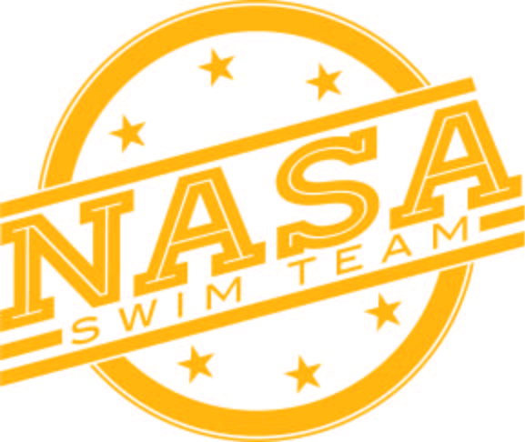
Northridge Area Swim Association
TEAM SPONSORSHIP

Date________________ NASA Member Name:________________________________________________

Business Name:__________________________________________________________________________

Business Contact Name/Title:_______________________________________________________________

Business Mailing Address:__________________________________________________________________

Email Address:______________________________ Website Address:______________________________

Meet Sponsorship Level/Print Ad Size:

Platinum: $2000: (3x2 banner with company logo, logo on website, naming rights to one NASA swim meet/company name on all meet apparel for that meet)

Gold: $750: (3x2 banner with company logo on pool deck, logo on website, logo on concessions menu)

Silver: $500: (logo on website, logo on concessions menu)

Bronze: $250: (logo on website)

Starfish: $100 (name on website)

*****Deadline for inclusion in all 2023-2024 NASA meets will be October 1, 2023*****

Please make checks payable to: NASA Swim Club

Businesses may mail check and sponsorship form to: NASA Swim Club
Seth Cripe
56779 Northridge Drive
Middlebury, IN 46540
NASA members can place check and sponsorship form in the lockbox/dues box at either pool. Please label checks in the memo as a Sponsorship. A completed sponsorship form must accompany check!
Submit your artwork, logo or business card electronically to Brittany Hembree @ bnhembree@me.com

